**Assignment 02**

**Zirwah Khalil i220748**

**Computer Networks A**

**Question 1**

**Explanation:**

Teacher Client is asked to verify, once teacher is verified, he/she can update the database. Teacher clients (TCP) send requests to the server and the server saves those changes in the database. Whereas the Student clients (UDP) can only view his/her details. Thus, it can only request to view its details from the server.

**Server:**

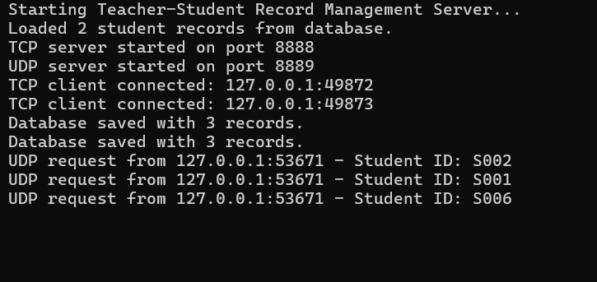

**Teacher (UDP Client):**

**Teacher 1**

**Teacher 2**

**Student (TCP Client):**

